Friends of the  Stockton and Darlington Railway |  | 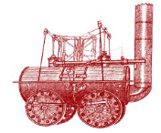

Minutes of Meeting held | Thursday, 3rd November, 2022
Location | Darlington Cricket Club
7.00 pm
Members Present: Niall Hammond NH (Chair), Jim Atkinson(JA), Peter Bainbridge (PB, membership secretary), Ian Ross (Treasrurer), Paul Boden (PB), Mike Brown (MB), Ed.Chicken (EC), Ross Chisholm (RC, Planning Officer), Sue Clarke (SC), John Dinsdale (JD), John Dixon (JD), Jane Hackworth-Young (JH-Y), Chris Lloyd (CL), John Raw (JR), Dave Reynolds (DR), Peter Spence(PS),Leigh Taylor (LT), Tim Taylor (TT), Barry Thompson (BT), Alan Townsend (AT, Asst. Secretary, Vice Chair) , Maurice Burns & George Alderslade

1.  2.  3.  4.  5.  6.  7  8.  9  10.  11.  12. | Apologies for absence. Alan Macnab, Angela Pickering (AP), Sue Fleury, Paul Harle, Matthew Pease, Trevor Horner, Caroline Hardie, John Fletcher, Yvonne Richardson, Richard Wilson, Ken Bradshaw, Richard Cowan, Athena Tallentyre; Alison Overfield, Edward Hirst, Norman Hugill, Jolyon Potter, Alastair Culfic.  ----------------------------------------------------------------------------------------  Minutes of the previous meeting of the 1st September 2022 were approved after clarification that Network Rail were supportive of the 9/25 celebrations and were interested in making events happen  Matters arising  Nothing further  ----------------------------------------------------------------------------------------Declarations of Interest None  -------------------------------------------------------------------------------------------------------  Chair’s report (APPENDED)  NH reported a meeting over the consultants’ report on possible governance to support the line after 2025. Various possible combinations of local authority, FSDR and a new body had been discussed, but the meeting workshop favoured having a single body.  He reported that work on the Durham County part of the walking and cycling route was going quite well, but was up against a deadline of March, 2024. Stockton and Darlington had different deadlines for completion of Levelling Up Fund projects.  The Heritage at Risk project now had enough volunteers for training on the 16th and 17th November.  In discussion: there was concern that consultation with lineside residents was somewhat inflexible, being confined to actual Planning applications. We will devise more community engagement.  Questions indicated concern over the limited amount of material on the TVCA website  Planning Officer’s report (APPENDED).  Item 2o;  RC reported that the planning officer was recommending that permission be granted at the Planning Applications Committee on November 9th and that his report did not properly address the issue of the impact of the proposals on the setting of the S&DR.  After a discussion the Chair agreed to email members of the committee and other key council members about our concerns and to address the committee meeting.  Chris Lloyd agreed to arrange an article in the Northern Echo.  2r. The proposal for a tall barn and separate “tack room” near the line north west of Middleton St. George took no account of their bearing on the line as a historic feature and recreation route. We will send off our negative opinion.  ____________________________________________________________ Presentation ‘Mind the Gap’, preserving the setting of the S&DR between Darlington and Aycliffe (RC & NH) (APPENDED)  The original rural and attractive gap in building near the line between Heighington Station and the edge of Darlington will be narrowed further by the Forrest Park development and the proposed solar farm. RC and NH consider the time is ripe to recognise the importance of physical separation in the next five year review of both statutory plans, whether or not the status of greenbelt is invoked. The matter was agreed for discussion by Trustees.  --------------------------------------------------------------------------------------------------------------  Presentation FSDR Quaker Project (supported by Historic England)  AT gave a summary presentation of work so far, as an invitation to members to join the Workshops beginning on November 26th. The S&DR was one of about 50 major Quaker firms originating in the C18 and C19, and there were real reasons why Quakers went into successful business. Quakers bought the majority of shares and occupied the majority of management posts in the line, and dominated the affairs of the S&DR till its merger with the NER in 1863.  Questions on circulated Officer Reports (APPENDED)  The deadline for the next edition of the GLOBE was 2nd December.  Receiving collections of railway books remained important, whether for our library or ongoing sale.  ____________________________________________________________________  Reports from FSDR Area Groups  BIG The maintenance funding of the incline had been signed off but was still on the way  MSG Catherine Gilsenan had notified the Parish Council of her resignation, which put the future of the steering group in some doubt. There had been some delays, with knock-on effects, in Storey Homes input.  Stockton Council were unsure, for budgeting reasons, about next year’s anniversary event. We would want to pin down its date as 23rd September. We had found a shed for the model of Locomotion, in a contractor’s compound.  WASH The group are now ready and willing to work with our neighbours across the fence DCC.The group are running a Xmas raffle to raise funds and extending an invite to all Friends to a Xmas party in the former Station Master Home on 16th December.  EIWPC The Group have recently produced a booklet (£2.00) on early incline working in the area. The group will be displaying at Toft Hill Christmas Fair, 26th November. Consultation between D C C local councillors and Parish Councils has begun with regard to the Walking Cycling Route, with the next meeting scheduled for January 2023.  Any other business  There were requests for information on: the 2025 celebrations; DBC’s use of the Locomotion replica; the work of the A1 Trust; and the renewal of contract of the HAZ officer.  There was news of a Darlington bid for funding of a musical on the 200th anniversary: FSDR would expect to be asked to check the script for accuracy.  This was to be seen alongside Stockton’s plans, both overseen by the Rail Heritage Partnership.  -------------------------------------------------------------------------------------------------------Date of next meetings  December 1st, Railway Tavern, Darlington 7 pm  February 2nd, location to confirm  ________________________________________________________  Chair’s Report/activity for September and October 2022  With our AGM being held in October there was no monthly meeting and so I have the pleasure of reporting on two months’ worth of activity. Firstly a big vote of thanks to all who helped organise, run, speak at, and attend our AGM held at Locomotion in Shildon. A thoroughly enjoyable day and I think the decision to make this more than just an AGM and to include a range of speakers was justified. There has been so much research and activity on the S&DR in the last few years I feel we should take every opportunity to present this back to members and the public. Presentations on the overall project by the HAZ Officer Richie Starrs, detailed research on Edward Pease’s House by Caroline Hardie, The Shildon Coal Drops by Marcus Jecock of Historic England and all concluded with the ‘First Rail’ animated film by our own Stockton Group made for an excellent day. Let’s look forward to doing it again next year. We also welcomed two new trustees elected at the meeting John Raw and George Alderslade. I’m grateful for their volunteering and to existing trustees for continuing their work.  Events to celebrate the annual ‘birthday’ of the S&DR creep nearer to the 200th, with an excellent Rail Heritage Fair in Stockton Market Place on the Saturday 24th September to mark 197th once again attracting a big attendance, and a smaller invitation walk from Witton Park to St Helen Auckland on the 27th being an enjoyable commemorative social event for Friends. Thanks to the organisers and hosts.  With regard to conferences and talks, both myself and our Vice Chair Alan Townsend have been invited to join the organising committee for the Early Railways Conference. The ERC has been meeting at various venues around the country over a number of years pushing forward research and understanding of early railways. The ERC are keen to make sure they hold their conference in the region in September 2025 and so we will be working closely with them to help arrange a suitable venue and encourage papers and research on the S&DR to be prominent in the programme.  Lots of meetings continue to make progress on a number of fronts as usual; These have included a series of meeting with a wide range of partners organised by Peter Gibson MP to look at the state, access and condition of North Road Station (the operational bit not the museum). This is widely agreed to be a woeful entry point to the new museums and does not do justice to the history of the S&DR. It is also poor for current rail users and if plans for charter steam specials to the area are to be realised then the station needs drastic improvement. Peter Gibson’s initiative has got all the right people talking and there will be improvements but sadly this may be too little too late for 2025.  On Tuesday 11th October I was invited to County Hall in Durham to present to an invited audience of Durham councillors, parish councils and officers as part of feedback on progress of various initiatives to do with the S&DR and in particular spending the awarded Levelling Up Fund monies on the Durham part of the S&DR walking and cycling route. Lots of impetus and enthusiasm to deliver this, but again the short remaining timetable to address concerns and to design, tender and build the track is challenging with the grant having to be spent by March 2024.  Volunteering is a key part of our project and we are still keeping our fingers crossed for a successful lottery bid in December which will provide extra resources to help support and run this more efficiently. In the meantime we look to work with other partners to combine rather than compete for volunteers. This month we met with Eileen Perrie at Locomotion to look at how we can work together on a variety of initiatives.  Our school’s education project continues to develop and we hope very soon to have a final ‘work pack’ designed for primary (KS1 and 2) to be shared by ourselves and all those working in education along the line. Education and care of a different kind is also being looked at this autumn with the launch of a partnership project we are calling ‘Caring for the S&DR’. This is intended to be a better way of people reporting problems from blocked railway paths to graffiti; fly tipping to historic building decay. Two training and information sessions have been arranged for this on the 16th and 17th of November at Locomotion and Head of Steam between 2-4 pm. Volunteers need only attend one of these and all are welcome. Email info@aenvironment.co.uk if you’d like to attend.  Finally our support of the study being undertaken by Tricolor Associates (Project 15 of the HAZ) which is looking at the long term post 2025 care of the S&DR is nearly complete. A final workshop with key partners is due in early November and a report by Christmas. This is exceptionally important not just for the long term care of the S&DR but also to provide a clear vision of the role of the FSDR in this. A full briefing will be provided in due course once the report is available.  Niall Hammond, Chair  Friends of the S&DR. 30/10/2022.  --------------------------------------------------------------------------------------------------------------Planning Officer’s Report; S&DR Friends Meeting 3 November 2022  New items and decisions made on applications since the last report are in red type. Any updates will be reported at the meeting, otherwise Items will be taken as read unless members have questions to ask or comments to make.  1 DURHAM COUNTY  j DM/22/01482/RM Approval of reserved matters (appearance, landscaping, layout, scale and access) for the erection of 8 industrial units at Forrest Park phase 1  Further to September’s report, permission was granted by delegated officer authority on 20 October.  A comprehensive plan was been submitted showing details of the footpaths and bridleways to be diverted and improved. This includes options for the S&DR Walking and Cycling Route (now called the Active Travel Route by the Council), with surfaced cycleable bridleways within a 5 metre green corridor with no overhanging planting. The existing bridleway south to Coatham Lane is outside the application site and is in Darlington. It will need to be improved to be suitable for cyclists. The promise of the informal temporary footpath along the railway line was made outside the scope of this application, but it would be reassuring to have it confirmed. We have also been informed that the owner of the field outside the north west corner of the site has agreed that this path can follow the railway.  The following are extracts from the officer’s report, summarising the situation;  The Friends of the Stockton & Darlington Railway: Note the provision for the proposed S&DR Walking and Cycling Route as shown on the Master Plan 63315-141 Rev F. As The Friends have been informed informally that the developers have agreed to allow a permissive footpath to be provided along the western (railside) boundary of the site until such time as rail access  is required to serve development on adjoining land, they raise no objection to the application subject to the developers confirming the above undertaking.  The Friends of the Stockton & Darlington Railway, BHS, BA Cycling club and Rights of Way Officer also raised concerns over the width of the bridleway. PROW officers required further detail in relation to details of the ground beneath the route, specific surfaces and layout of the PROW and connections to the north and offsite improvement works. The applicants have submitted amended plans to address these concerns and the Rights of Way Officer is willing to accept these subject to no works to paths commencing until the TCPA is finalised. An informative will suffice in relation to this matter. The details are therefore considered acceptable to discharge this condition.  We await confirmation of the permissive lineside footpath, although this matte is now in the hands of the Heritage Action Zone’s Walking and Cycling Route Officer. He will be reporting progress on all aspects of the Route in the near future.  k DM/22/01891/FPA Craggwood Holiday Park proposed extension  Further to September’s report, the site meeting revealed that the embankment of the Haggerleases Branch forming the application site appears to have been widened and possibly heightened in places by tipping in recent years. This suggests that the works to site the caravans there are unlikely to harm anything of remaining heritage value. However we still have reservations about the application and the following need to be attended to before we can withdraw our objections;  1 The County Archaeologist needs to confirm that there will be no harm to the heritage value of the site, subject to a watching brief during construction;  2 Proposals to stabilise and landscape the embankment with gabions, etc should include cross-sections of the proposals and detailed drawings showing how backfilling, planting and fencing will create an appropriately attractive setting to the former line and not physically harm the heritage value of the embankment;  3 The site owner and the County Public Rights of Way Officer should negotiate agreements to maintain the public footpath alongside the line in good condition and suitable for use throughout the year.  l Proposed Bluestone Solar Panel Farm, High Lands, Cockfield  Further to September’s report, Alan Townsend (Vice Chair) and I had a Zoom conference on 10 October with developers the Bluefield Group and their consultants Alpaca Communications. They described their proposals which will accommodate existing public bridleways and footpaths within the site in enhanced landscaped corridors. The proposals are unlikely to have any physical or visual impact on the setting of the Haggerleases Branch. They are drawing up a list of potential public benefits, which include providing information panels describing the area’s mining and railway heritage. They are willing to consider opening up the ‘High Line’ as a footpath and they will consider helping us in our endeavours to promote the Haggerleases Branch, such as assisting the funding of a walks leaflet.  A public exhibition of their proposals is planned for later in November.  2 DARLINGTON BOROUGH  f 21/00529/FUL Residential development comprising of 260 no. dwellings including access, open space, landscaping, sustainable drainage systems and associated infrastructure and works Land To The West & South Of Station Road Station Road MIDDLETON ST GEORGE  Further to previous reports, this application is yet to be decided. We have been asked to suggest how the developer’s contribution of £10000 towards rail heritage projects at Fighting Cocks should be spent.  m 21/01353/FUL Site of Former Corus Works (East Site) Whessoe Road DARLINGTON  Further to September’s report, revised plans have been submitted and we have been asked by the planning officer for our comments and advice. The plans now show a full road access to Elmtree Street; this resolves the main issue and can allow the link to be provided to the S&DR Walking and Cycling Route. The removal of all trees, mostly self-seeded since the Rolling Mills buildings were demolished, and minimal planting along railway boundary may have an impact on the setting of the S&DR/Bishiop LIne and this should be addressed by the developer.  We have submitted the following comments;  1 Thank you for requesting the comments and advice of the Friends of the S&DR on the recently submitted amended plans. 2 We are pleased to see that a full vehicular access is to be provided from Elmtree Street. This should be designed to enable the link to the proposed S&DR Walking and Cycling Route alongside the line to the north of the overbridge to be constructed. We assume that the Council's Highways staff will be liaising with the developers to agree the detail and ensure that this happens.  3 We suggest that a condition be attached to a permission requiring this access to be constructed and available for public use before any of the dwellings are occupied. This to allow the path link to be completed before the 2025 anniversary activities take place.  4 In our comments on the initial proposals on 21 January we expressed concern about the loss of trees and the possible impact of this on the setting of the S&DR/Bishop Line. We repeat our recommendation that the applicants be required to make this assessment so that the application can be considered against Local Plan policy ENV2.  n 22/00423/FUL Industrial development comprising the erection of 3 no. industrial buildings. Land East Of Lingfield Estate  Further to previous reports, this application has yet to be decided. If approved, the development will include landscaping along the Tornado Way boundary, helping to maintain the setting of the S&DR.  o 22/00213/FUL Installation of a solar farm on land north of Burtree Lane  Further to September’s report, revised plans have been submitted and these continue to include arrays of panels at the northern end of the site together with four metre high hedges alongside the motorway and next to the accommodation bridge under the embankment (see plan below). We have not, to date, been asked for our comments, but we have the Heritage Action Zone Projects Officer, Richie Starrs, has asked the Planning Officer to meet us on site to discuss the issues  that need to be resolved. We will consider our position after the meeting.  p Greater Faverdale (Burtree Garden Village) Design Code SPD  Further to previous reports, we were notified of the results of consultation on the draft Design Guide and the resulting changes. However the officers’ report makes no reference to our comments submitted on 3 May and I have asked for an explanation for the omission. No reply was received to this request so a reminder was sent; no reply to that either.  q 22/00352/DC and 22/00353/DC Land At Central Park John Dixon Lane, with construction of footpaths, installation of artwork features, seating, etc.  Further to September’s report, the County Archaeologist has approved the Written Scheme of Investigation and we will ask to receive a copy of the reports of the findings. It is now proposed to carry out the works in phases, to be completed when details of the adjacent developments are known.  r 21/01344/FUL | Erection of a barn and a separate tack room building | Middleton Riding Centre Sadberge Road MIDDLETON ST GEORGE DARLINGTON DL2 1RJ  We have been asked for our comments and advice on this application adjacent to the Fighting Cocks Branch north west of Middleton St George. The submitted Heritage Statement underplays the importance of S&DR as a visitor attraction and the use of the trackbed for walking and cycling. It is unclear how the proposals will affect the countryside setting of the S&DR and there is no assessment of how visible the buildings will be from the trackbed path. We have until 8 November to respond.  3 STOCKTON BOROUGH  e 22/0664/FUL Application for new access roads and 100no vehicle car park at Eaglescliffe Station Further to previous reports, we are still waiting for confirmation that we will be consulted on the details for the car park.  f 22/0931/FUL Erection of dwellinghouse incorporating the existing detached garage at Copsewood , The Avenue, Eaglescliffe  Further to previous reports, this application still remains undecided.  3  g 22/1084/VARY Reserved matters application for the access, appearance, landscaping, layout and scale for residential development comprising 845 dwellings. Allens West Logistics Centre Durham Lane Eaglescliffe.  Further to September’s report, permission was granted by delegated officer authority on 5 September. It was explained that the application referred only to house types and the officer report states;  Comments from the friends of Stockton and Darlington Railway are noted, however the proposal plans are as the approved scheme. The cycle route is to be provided by others and does not form part of the scheme under consideration. The Heritage Action Zone Walking and Cycle Route Officer now has the matter in hand.  h 22/0812/FUL Erection of rear extension incorporating existing detached garage, etc, 604 Yarm Road Eaglescliffe  Further to September’s report, permission was granted by delegated officer authority on 18 October. The following is an extract from the officer’s report;  Concerns have been raised by the Friends of Stockton to Darlington Railway regarding the location of the proposed works, however since the original submission of the application the proposal has significantly been reduced and would no longer include demolition or extension works. As a result of the amended scheme objections are no longer raised by the Landscape Officer or SBC Historic Buildings Officer.  i 22/1746/FUL | Erection of a two storey rear extension, hip to gable roof extension to include the installation of 2no dormer windows to front and 2no dormer windows to side. | 505 Yarm Road Eaglescliffe Stockton-On-Tees TS16 9AR  Further to September’s report, a Heritage Impact Assessment was submitted and permission was granted by delegated officer authority on 18 October. The following is an extract from the officer’s report;  In this location the original line of the S&DR is not apparent, is not publicly accessible and the area of the line shown on the local plan policies map would appear to cut through the existing extension at the property. The local planning authority has no evidence of any underground remains remaining here or surviving in situ. The proposal would not extend any greater beyond the existing rear, however it would square off the existing off-shoot where there is an existing patio area laid. It is rather difficult to establish that such a development of that already carried out would have an adverse impact on unknown heritage assets. Tees Archaeology have assessed the submitted heritage statement provided comments. Due to the 1930’s build an subsequent extension at the property it is considered any remains of the former railway will have been negatively impacted upon as a result. To conclude, in this particular case it is not considered necessary to seek any further archaeological monitoring.  4 MIDDLESBROUGH  a Proposed new Local Plan  The Borough Council has decided to prepare a new local plan. We will campaign for a policy to protect, enhance and promote the 1830 extension of the S&DR to Middlesbrough, including the heritage of Port Darlington and the New Town.  Ross Chisholm,  Planning Officer  27 10 2022  .  .----------------------------------------------------------------------------------------------------- MAINTAINING THE RURAL GAP BETWEEN DARLINGTON AND NEWTON AYCLIFFE  1 200 years ago, the 42 km route to be followed by the Stockton & Darlington Railway was almost entirely through rural farmland until it reached the quayside at Stockton. The railway brought about development at New Shildon, the North Road area of Darlington and at Fighting Cocks, but little change elsewhere. This remained the picture for over 100 years until the post war creation of Newton Aycliffe new town and its Industrial Estate on the former Ordnance Factory site. There was a significant gap of 5.2 km between Heighington Station and the Rolling Mills on the edge of Darlington, although this reduced to 4.0 km after the subsequent development of the Lidl regional depot and the Hitachi railway works.  2 But this situation is set to change. The Forrest Park industrial development will extend Newton Aycliffe to the county boundary. The Berrymead Farm and Burtree Lane housing sites are extending Darlington further northwards and the proposed Burtree Garden Village will extend up to Burtree Lane west of the railway. These developments will reduce the rural gap along the railway to 2.6 km.  3 The proposed solar panel farm north of Burtree lane is if concern. If approved in its currently proposed form, it will extend development north to the railway bridge over the A1(M) and reduce the gap to a mere 1.1 km.  4 The gap between the two towns is experienced not just on the Bishop/S&DR Line but also on the A167, the East Coast Main Line railway and the A1(M). Despite ribbon development alongside the A167, there is a clear sense of separation but this will be reduced by proposed housing development extending the built up area north and east of Beaumont Hill.  5 Before preparing the current Local Plan, Darlington Council issued a strategic development map. This identified growth zones extending north to an arc created by the A1(M) and a new Northern Bypass. This effectively coalesces the two towns, separated only by the A1(M). The plan may have no formal significance but it is evidence that the Borough Council has considered such a strategy to be acceptable in the long term.  6 The need to recognise the importance of retaining the physical separation of Darlington and Newton Aycliffe should be addressed by the respective councils with a view to adopting interim policies pending the forthcoming statutory five-year review of their adopted local plans. Whether it is appropriate to designate a statutory green belt will be a matter for debate, but boundaries should be identified now, before further reductions are approved. Darlington’s Local Plan Policy ENV 3 should be expanded to include the separation of Darlington from Newton Aycliffe. There is also a case to protect the separation of Darlington and Middleton St George.  7 Where development extending the built up areas of Darlington and Newton Aycliffe takes place alongside the former S&DR line, the harm created by the loss of the existing countryside setting should be made good by appropriate screening, tree planting or other carefully designed landscaping. This will ensure that an attractive new setting for the line, and the walking and cycling route that follows it, can be achieved. This applies particularly to proposals for Forrest Park, Burtree Garden Village, Burtree Solar Panel Farm (if approved), land to the east of Lingfield Estate and the Great Burdon housing allocation. Developers should be made aware of this requirement at the outset and a landscaped corridor should be included in their master plans.  8 Such a policy would be consistent with Darlington Local Plan policy ENV4 and County Durham Plan policy 26, which recognise the S&DR as a corridor in the Green Infrastructure Networks.  Ross Chisholm  FSDR  30 09 2022  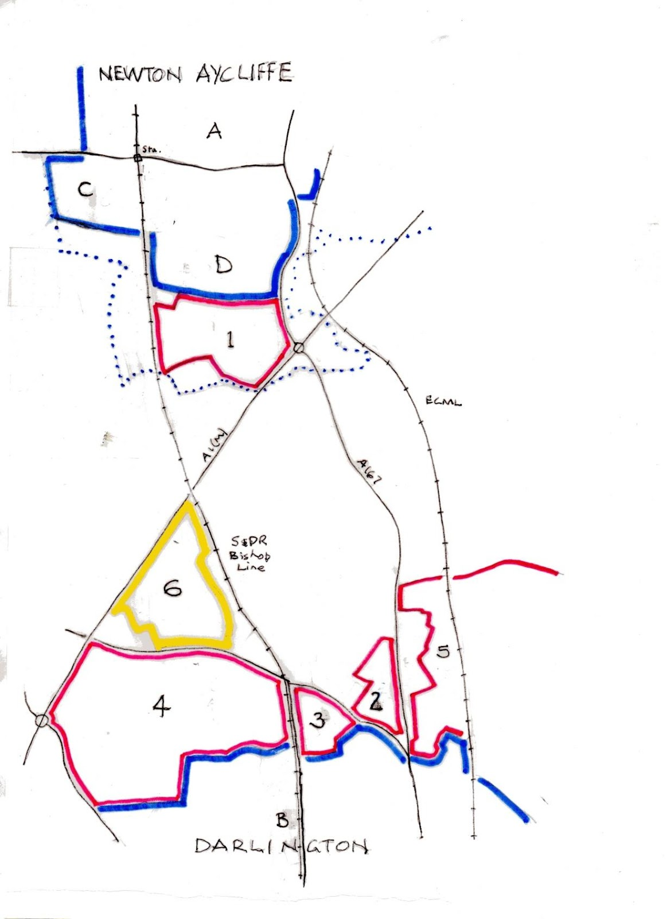  A Newton Aycliffe Industrial Estate; B Darlington Rolling Mills; C Hitachi; D Lidl  1 Forrest Park; 2 Berrymead Farm housing; 3 Burtree Lane housing; 4 Burtree Garden village;  5 Beaumont Hill housing; 6 Burtree Solar Panel Farm.  . . . . . . Darlington/Durham boundary  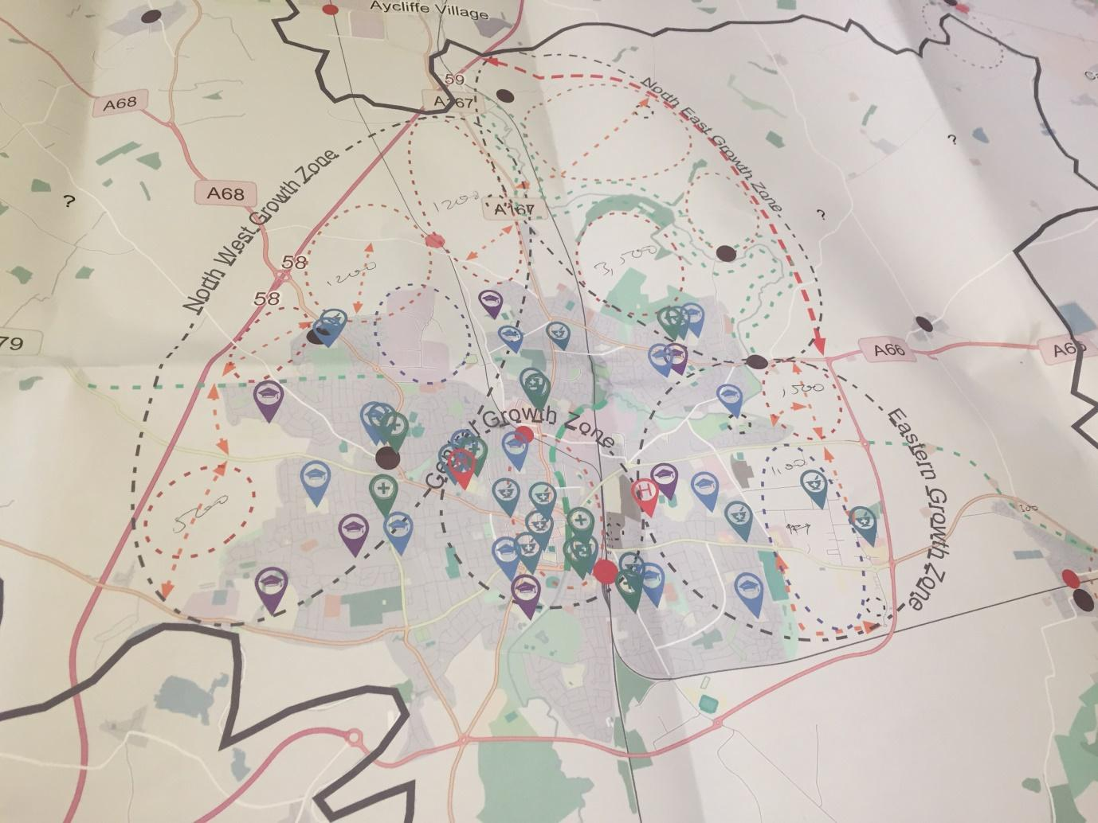  Darlington BC Strategic Development Map  ___________________________________________________________ | NH  RC  RC, NH,  Trustees  AT  RC  BT  JR
1.  2.  3.  4.  5.  6.  7  8.  9  10.  11.  12. | Report from Caroline Hardie, editor, web master and general dogsbody  1. The deadline for contributions to the next Globe is 2nd December.  2. I am gradually uploading more second hand railway books to the Friends online shop at https://www.sdr1825.org.uk/store/. You will also find some of our own publications there, so do consider exploring our web site for Christmas ideas and in doing so help us to raise funds. Buying second hand is better for the planet!  3. In the last month the web site has sold 11 products generating £150.50 net sales, the bulk of sales being the AGM and New Membership.  4. The AGM seems to have gone well. We ran at a slight loss due to purchasing some equipment which we will use again at future events. The venue was free, and we are grateful to Locomotion for providing it (and for opening Kilburn’s Warehouse) but feedback suggests that the acoustics were echoey and the plumbing capable of drowning out a speaker, so we will look for an alternative venue for next year. Moving the venue around is a good idea in any case. Suggestions welcome. Thank you to the speakers for providing their time and expertise and thank you to everyone who came.  Membership report – 31.10.22  2021 to 2022  Fees & Donations :- Ordinary Members - £2517.11 (including donations of £367.23)  Corporate Members - £974.45  Total - £3491.56  Gift Aid on membership fees and donations - claim to be submitted to HMRC.  Membership as of 26 September 2022  Ordinary Members – 210.  Corporate Members – 20.  Membership renewal for 2022 to 2023 (Ordinary Members).  Renewal invitations issued to members on 10 August 2022 except for the following:-  Members who paid via Standing Order for 2021 top 2022.  Members who have set up a Standing Order for 2022 to 2023 and beyond.  Renewal reminders issued to members on 13 September 2022 except for the following:-  Any members who had paid their fees since 10 August 2022.  Any members who had set up a Standing Order since 10 August 2022 for 2022 to 2023 and beyond.  Final reminders issued to members on 30 September 2022 except for the following:-  Any members who had paid their fees since 13 September 2022.  Any members who had set up a Standing Order since 13 September 2022 for 2022 to 2023 and beyond.  Membership renewal final reminder - closing date is 31st October after which anyone who has not responded will be deemed to be a lapsed member and will be removed from our database.  Current membership status:-  Renewals – 144.  Fee for 2022 to 2023 previously paid (2021 to 2022) – 13.  Not renewing – 10.  Deceased – 2.  Pending – 4.  No response – 37. (Deemed to be lapsed members and removed from our database).  Re-joined – 5.  New members – 20.  Current membership – 182.  Membership renewal for 2022 to 2023 (Corporate Members).  Renewal invitations issued to members on 05/06 August 2022.  Renewal reminders issued to 2 members on 30 September 2022.  Current membership status:-  Renewals – 18.  No response – 2. (Darlington Borough Council & Rail Programme Delivery Partnership)  New members – 1.  Fees & Donations :- Ordinary Members - £2109.46 (including donations of £206.66)  Corporate Members - £949.10  Total - £3058.56  ---------------------------------------------------------------------------------------------------------- | NH  RC  RC, NH,  Trustees  AT  RC  BT  JR

