Planning Officer’s Report; S&DR Friends Meeting 1 December 2022
New items and decisions made on applications since the last report are in red type. Any updates will be reported at the meeting, otherwise Items will be taken as read unless members have questions to ask or comments to make.

1 DURHAM COUNTY

k DM/22/01891/FPA Craggwood Holiday Park proposed extension

Further to last month’s report, we are waiting for the applicant to submit details of how the Haggerleases embankment adjoining the site will be landscaped.

l Proposed Bluestone Solar Panel Farm, High Lands, Cockfield

Further to September’s report, Alan Townsend (Vice Chair) and I had a Zoom conference on 10 October with developers the Bluefield Group and their consultants Alpaca Communications. They described their proposals which will accommodate existing public bridleways and footpaths within the site in enhanced landscaped corridors. The proposals are unlikely to have any physical or visual impact on the setting of the Haggerleases Branch. They are drawing up a list of potential public benefits, which include providing information panels describing the area’s mining and railway heritage. They are willing to consider opening up the ‘High Line’ as a footpath and they will consider helping us in our endeavours to promote the Haggerleases Branch, such as assisting the funding of a walks leaflet.
A public consultation event is being held on Wednesday 7th December 2022 from 2pm to 7pm at Lands Village Hall, High Lands, County Durham, DL13 5AR. All are welcome and details of the proposals can be found via the link http://www.bluestonesolarfarm.com

n New wall at Unit 10 Hackwoth Industrial Park, Shildon

A new concrete panel wall, approximately 2.0 metres high, with taller floodlight poles, has been erected along the northern boundary of the scrap yard at Hackworth Industrial Park, replacing the steel palisade railings (see photo below). The boundary sits alongside the S&DR trackbed between the foot of the Brusselton Incline east and Masons Arms crossing. It will enclose the walking and cycling route which has woodland on the north side. It is likely to attract graffiti.
I am making enquiries into the effect this will have on the setting of the S&DR and on the enjoyment of visitors walking the line. I have notified the Council planners and they are investigating if the wall is authorised or needs planning permission. Meanwhile I welcome the views of the local group.

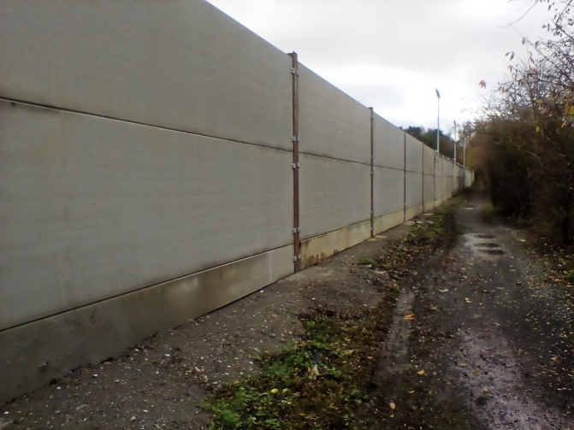

2 DARLINGTON BOROUGH

f 21/00529/FUL Residential development comprising of 260 no. dwellings including access, open space, landscaping, sustainable drainage systems and associated infrastructure and works Land To The West & South Of Station Road Station Road MIDDLETON ST GEORGE

Further to previous reports, this application is yet to be decided. We have been asked to suggest how the developer’s contribution of £10000 towards rail heritage projects at Fighting Cocks should be spent.

m 21/01353/FUL Site of Former Corus Works (East Site) Whessoe Road DARLINGTON

Further to last month’s report, no progress has been made to address the issues we have raised.

n 22/00423/FUL Industrial development comprising the erection of 3 no. industrial buildings. Land East Of Lingfield Estate

Further to previous reports, details of car parking have been submitted and we have asked for confirmation that the boundary fence surrounding the red parking area, together with proposed landscaping, will screen any views of areas of parked cars from the S&DR Walking & Cycling Route on the north side of Tornado Way.

o 22/00213/FUL Installation of a solar farm on land north of Burtree Lane

Further to discussion at last month’s meeting, permission was granted subject to a Section 106 agreement and conditions by the Planning Applications Committee on 9 November. We had previously circulated a statement of our concerns to members of the committee. The Northern Echo carried an article on 8 November. Our Chair addressed the Committee on the day, without success.
The outcome is that arrays of solar panels will be erected right up to the foot of the Myers Flat embankment and tall hedges will obliterate existing views of it and the surrounding countryside from the walking and cycling route. It is understood that the developers will pay towards the cost of creating the walking and cycling route and information panels in the vicinity of the site. Our Trustees have agreed to send an open letter to the Council’s Chief Executive expressing dismay at the decision.

p Greater Faverdale (Burtree Garden Village) Design Code SPD

Further to previous reports, we still have had no response from the planning policy team; another reminder will sent in stronger terms.

q 22/00352/DC and 22/00353/DC Land At Central Park John Dixon Lane, with construction of footpaths, installation of artwork features, seating, etc.

Further to previous reports, permissions were granted by officer delegated authority on 18 November. The following is an extract from the officer’s report;
‘the layout of the park will incorporate the layout of the railway and associated structures into the design, providing a positive benefit to enable communities to understand and appreciate this part of Darlington’s Railway Heritage. However, groundworks associated with the development will remove or truncate the archaeological remains, which the report states can be mitigated through archaeological investigation and recording.’
I have asked to be notified when the post-investigation assessment report is available
r 21/01344/FUL | Erection of a barn and a separate tack room building | Middleton Riding Centre Sadberge Road MIDDLETON ST GEORGE DARLINGTON DL2 1RJ

Further to discussion at last month’s meeting, the comments were submitted and these are attached at Appendix 2r at the end of this report.

3 STOCKTON BOROUGH

e 22/0664/FUL Application for new access roads and 100no vehicle car park at Eaglescliffe Station

Further to previous reports The provision of the S&DR Walking and Cycling Route through the site is now in the hands of the HAZ Project Officer.
f 22/0931/FUL Erection of dwellinghouse incorporating the existing detached garage at Copsewood , The Avenue, Eaglescliffe

Further to previous reports, revised plans for the new dwelling have been submitted. We have confirmed our support for Tees Archaeology, who continue to be concerned about the potential impact of the proposals on the adjacent route of the S&DR. The Council’s Historic Buildings and Design officers object to the building’s design.

4 MIDDLESBROUGH

a Proposed new Local Plan

Further to last month’ report, preliminary consultation on the new plan is intended to start later this month, but it looks like being delayed.

Ross Chisholm,
Planning Officer
26 11 2022

APPENDIX 2r

21/01344/FUL Erection of a barn and a separate tack room building at Middleton Riding Centre
Comments and advice of the Friends of the Stockton & Darlington Railway

1 The Heritage Assessment has a number of typos including a 100 year error in paragraph 2.4.

2 The Assessment rightly describes the site as marking the beginning of countryside and this reflects the character of the area and the setting of the S&DR as it was in 1825. It is important to retain this character.

3 The Assessment underrepresents the value of the trackbed path. The ’cinder track’ (para 3.4) was installed some years ago by Sustrans but was recently upgraded by the Borough Council with European Union funding. It is now 3.5 metres wide with a Whindust surface on a granular base. It carries National Cycle Network Route 14, linking Darlington and Stockton and it provides a sustainable travel route for Middleton St George residents accessing the employment areas at Lingfield Point and elsewhere in Darlington. Most significantly it will carry the continuous 26-mile S&DR Walking and Cycling Route from Witton Park to Stockton, one of a number of projects being managed by the S&DR Heritage Action Zone ( HAZ).

4 Consultants appointed by the HAZ have prepared proposals for waymarking and interpretation along the Route, including a package for the nearby Heritage Hub at Fighting Cocks. In all, the Route will become part of the S&DR visitor attraction of international importance and the third paragraph of Local Plan Policy ENV2, omitted from the Assessment (para 4.6), should be addressed. This states ‘Development proposals that support the development of the S&DR as a visitor attraction including the creation of walking and cycling paths along its route will be encouraged.’

5 The Friends challenge the statement (para 3.3) ‘the route resembles a standard right of way with few visual clues to its original purpose’. The path has every appearance of an abandoned railway line running through the countryside. So much so that the HAZ proposes to include it in a Conservation Area along the abandoned length of the S&DR between the A66 Darlington Southern Bypass and Mill Lane. This will elevate the status of the trackbed and accompanying features to a designated heritage asset and would add greater weight to the need to protect its setting. Sections A and B of Local Plan Policy ENV1 would become relevant, in addition to policy ENV2.

6 In view of the value of the heritage asset, the Friends recommend that the applicant gives more attention to the impact of their proposals. They should:
i Describe the appearance of the sites of the buildings as seen by users of the Walking and Cycling Route, including from the point just north of the A67 subway, where access roads merge,
ii Assess how the proposed development will affect this view, and
iii Propose remedial measures to avoid any adverse impact.

7 The size and height of the two proposed buildings are such that they will significantly add to and extend the existing nearby collection of buildings, thus adding to their impact against the countryside setting of the S&DR. There appears to be no evidence of equestrian activity taking place at present at the site and the Friends understand that the former riding centre building is now occupied by the plant hire depot. The application gives no indication of how the buildings will be used; the floor plans give no detail either. There is no explanation of what other activities will take place at the riding centre, such as horse box parking, stabling, outdoor training together with accompanying floodlighting and signage.

8 In view of the above, there could be additional impact on the S&DR asset and the Friends recommend that applicant should be required to clarify how the riding centre will operate. Following this the application should be considered against Local Plan policy E4.

9 If the proposals are such that planning permission can be granted, a condition should be attached restricting the use of the buildings to the permitted activities of the riding centre and for no other purpose.

10 The Friends are concerned that the proposed development would result in an increase in horseriding on the Walking and Cycling Route, causing added conflict with cyclists and pedestrians enjoying the S&DR visitor attraction.

