BIG
After some eight years of being manual workers this volunteering group have gone from workforce to foremen roles here. This is due the awarding of a £5,000 annual grant, from D C C for three years from September 2022.

The owners of the majority of land (D C C) have given over the day to day site maintenance to BIG. who look forward to working with new partners in the run up to 2025.

John Raw
26 November 2022

WASH

The most tangible step forward in this section of the original line has been a general tidy up by the farm of 500 metre area running up to the Hummerbeck Bridge. This has resulted in a view of the bridge not visible for a number of years.
The walking and cycling route from Hummerbeck up to Brusselton Bankfoot is eagerly awaited.

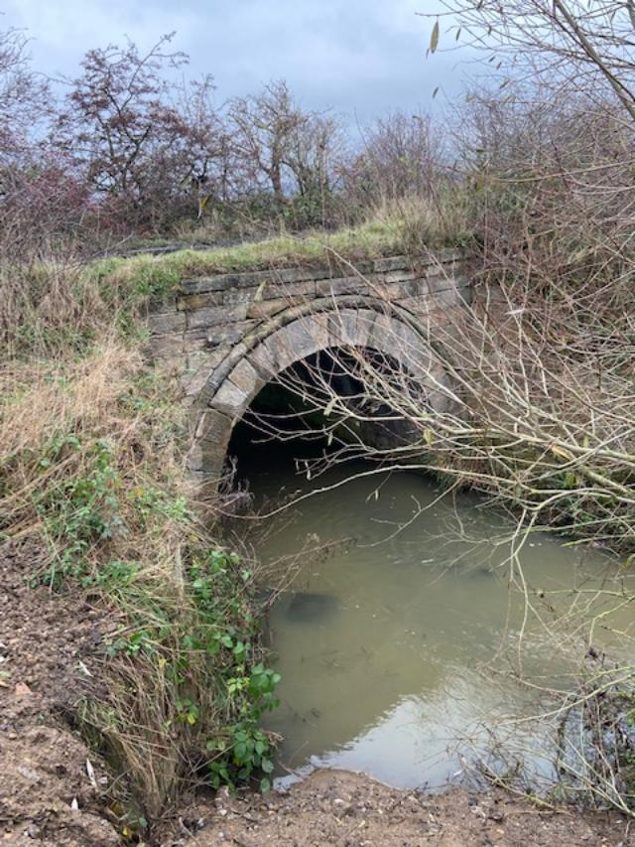

John Raw
27 November 2022

EIWPCG

The Etherley Inclines a Short History is having a good response and we are giving copies to all the Landowners along the Inclines. We took some copies to the Etherley Christmas Fair but only sold one. Alison, as Parish Clerk, has been involved in meetings with Durham C.C. about the Walking and Cycling route and expressed our concerns about having a bridleway. A group of us went down dismantled the encampment that had been built in the cutting beyond Greenfields.

Mary Smith
27 November 2022

