BIG
Progress is being made on this section of the track bed.

The tenders for work at both sites have been received and contractors appointed. Both with the ground nesting bird season looming in March. Pleased to be able to report that the major work has been carried out. At present an amount of snagging and planting up needs to take place at the former Masons Arms site.

Those at the G5 Open Morning on the 4th March will be able to view.

BIG has a meeting with Shildon Town Council, at the beginning of March, to seek their input.

The news from Historic England to amend/alter the status of Brusselton now for example to include in its protection both the former Milk Bridge and also the reservoir can be seen as excellent news.

We still await consultation from both DCC on the cycling and walking route Also from Bright White re signage along our section.

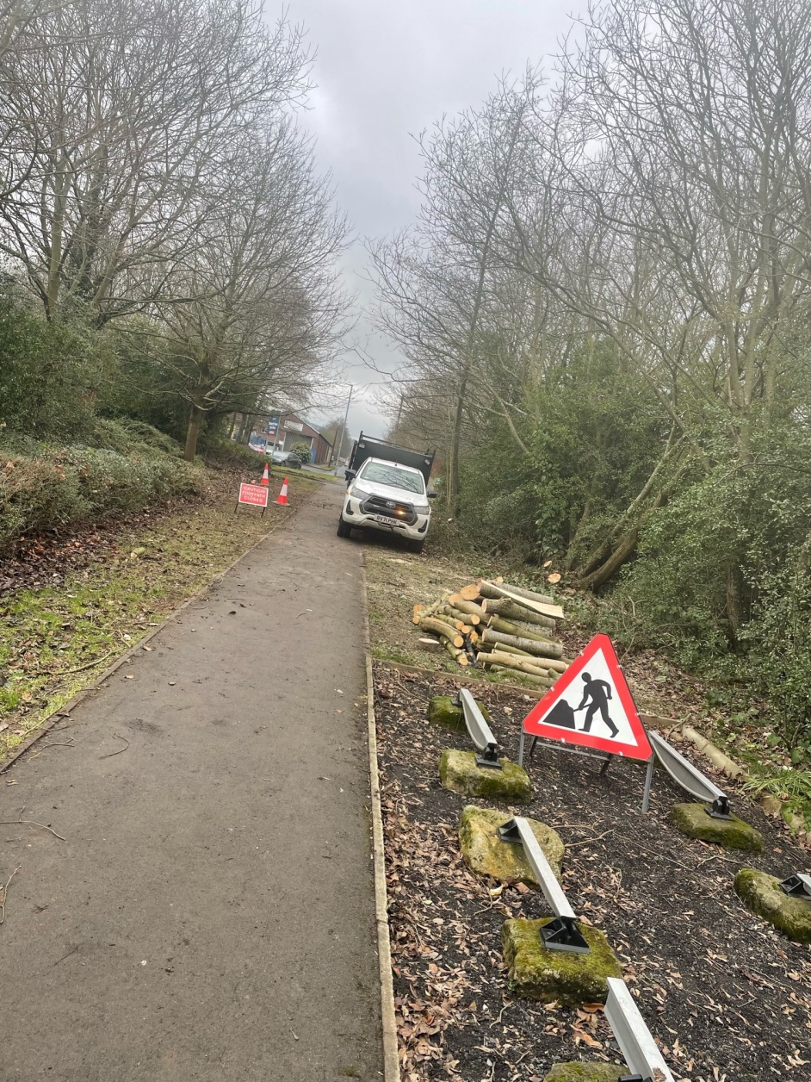

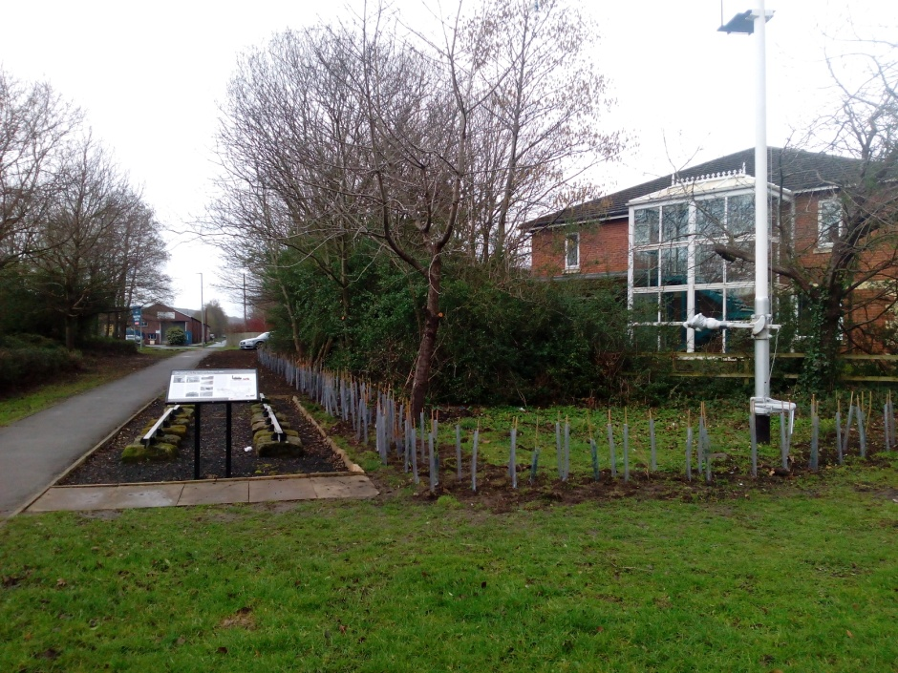

John Raw – 26.02.2023

WASH
The Group in some aspects continue to twiddle their collective thumbs as we await DCC plans /vision. Recently the owner of the 1871 former Station Master’s Home has erected his own wooden fencing. A litter pick of the DCC land in front has taken place.(see photos).

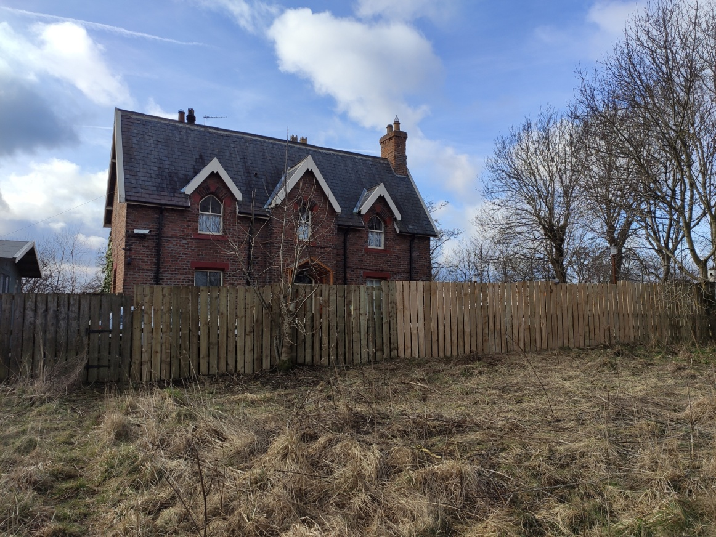

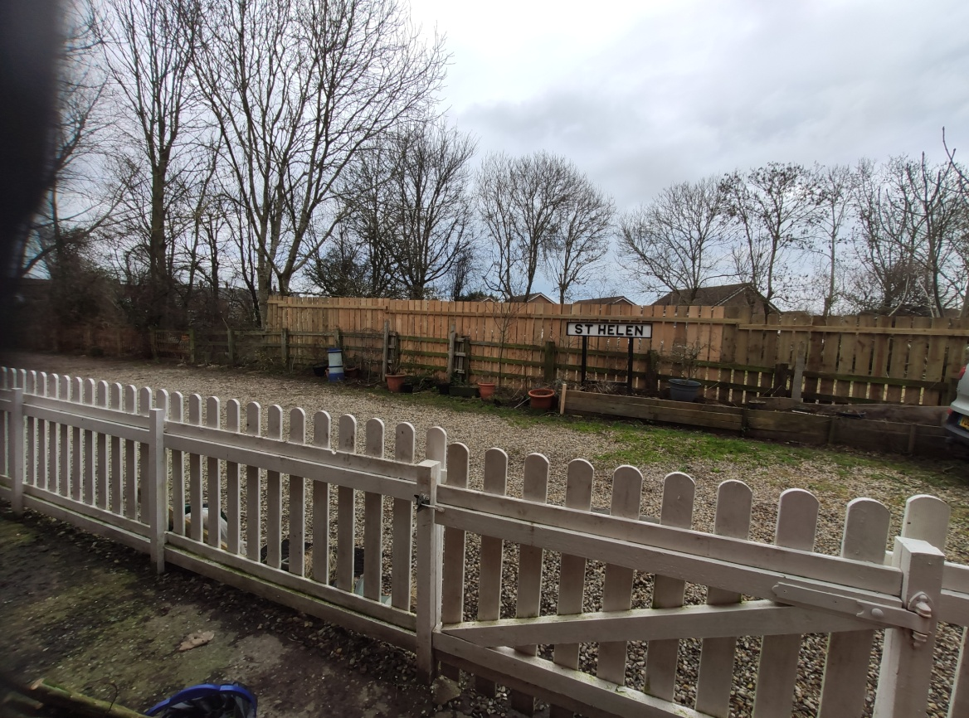

On Monday 6th March from 10.55 together with Northern Rivers Authority there will be an organized litter pick around the Gaunless. Open to all, please turn up in driveway of St. Helen, former station; suitable foot ware, hand tools and with a can do attitude.

Historic England has awarded DCC £161,000 for the repair and restoration of the stone abutments over the Gaunless. DCC’s Levelling Up Fund allocation will provide funding for new decking for the walking/cycling route across the river linking St Helen to neighbouring West Auckland.
John Raw – 22.02.2023

