Friends of the  Stockton and Darlington Railway |  | 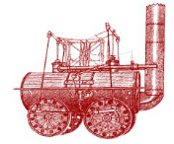

AGENDA

Date | Thursday 4th May 2023
Location | Darlington Railway Institute Club, 93 North Rd, Darlington DL1 2PP
Time | 7:00pm

- Apologies for absence.

- Minutes of the previous meeting.

- Matters arising.

- Declarations of Interest.

- Chair’s report (NH/AT)

- Updates on 2025 Planning

- Planning Officer Report:

- Questions on circulated Officer Reports (all)

- Reports from FSDR Area Groups

- Any other business.

- Date and time of next meeting. 7pm June 1st . Darlington Cricket Club, South Terrace, Darlington DL1 5JD.

