Editor’s and Webmaster’s Report covering April 2023
The Globe
Articles are slowly being gathered for July’s Globe. So far, we have contributions covering the Raisbeck and Henry Pease archives, the Linz to Budweis Railway (because we are an outlooking group!), giving S&DR inns their rightful place in the national listings, research into the Morgan family (engine drivers and gatekeepers for the S&DR (police), and interesting snippets from various archives. There will also be the usual news updates. Potentially the July Globe could be a bumper edition, so I’d be happy to hear from anyone who would like to contribute. My contact details are below.
Self-guided Walks Booklets and Folder
Thanks to funding from Brightwater, the self-guided walks booklets covering West Auckland to Shildon and the Shildon Circular have been wholly redesigned and updated. Many thanks to all the volunteers who participated and to the designer Maud Webster who was a pleasure to work with. The new booklets (and the other ones) can be purchased here: https://www.sdr1825.org.uk/store/
We hope to embark on redesigning and updating other booklets in the series once the walking route has been fixed.
We also now have attractive folders which will hold all your walks booklets or about 11 Globes. These can also be purchased here: https://www.sdr1825.org.uk/store/
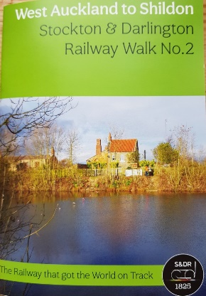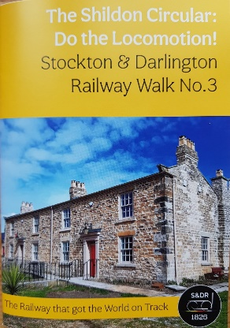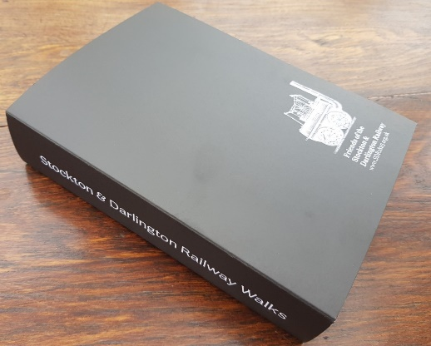
The Black Boy Branch
The Black Boy Branch Trackbed Audit now exists in draft form and will be circulated for comments to all volunteers who participated. There is a small delay while I wait on a couple of things that need adding. Many thanks to everyone who joined me on the fieldwork and to John Raw who assisted with the arrangements for the fieldwork and refreshments at Eldon’s One Stop Shop with a brief talk from Colin Turner. Colin was very generous in sharing his research and has kept us on track. Thank you too to Maggie Pulle for looking out archival material from the National Archive and to the top team (Trevor Horner, Ken Todd and Barbara Brown) for transcribing them. Maggie is uncovering more material all the time which will shine a light on the less well-known individuals who worked on the S&DR. Tom Walker and Jane Hackworth-Young were able to furnish me with more information about the Greener family who worked on the Etherley and Black Boy inclines.
Railway Taverns
The Historic England funded research into the S&DR Railway Taverns is finally nearing completion. It has taken considerable amounts of time to comment on this and get it right. A huge amount of research was carried out at The National Archive by the consultants WSP which will prove to be very useful. The next stage is to look at publishing a book on the railway taverns along the S&DR using much of the research carried out by the late Brendan Boyle and WSP. This will require funding, so our next task will be to find it.
Web site www.sdr1825.org.uk
I have added the Lime Cells report to our Online library and soon the Black Boy report will join it. Mary Smith’s leaflet on the Etherley Inclines is back in stock in the shop along with our updated walks booklets and folder.
In the last month sales have been only £80.24 – the best seller was Mary Smith’s Etherley history (5 copies). Otherwise, we have sold 4 new memberships, one renewal, one copy of Mike Norman’s new book ‘It wasn’t Rocket Science’ and one of our new booklet folders.
With support from Historic England’s Heritage Schools Programme, our Education Page is now up and running with lots of free downloads. This has resources about the S&DR, designed to support KS1-2 educators and students. It can be found here: https://www.sdr1825.org.uk/education/
In terms of web site development, I hope to add more People of the Line (mostly engine drivers) to our web site over the next two months; this thanks to the work of Maggie Pulle.
If anyone would like to help me develop the web site content further, please get in touch.
Caroline Hardie
caroline@aenvironment.co.uk

